**Data Analysis Report: Accidents Servay**

*Executive Summary:*

This data analysis report presents an in-depth examination of accident data over the past year to identify trends, contributing factors, and potential strategies for improving road safety.

We collected and analyzed accident data from UK for 2012 to 2014. The analysis involved both charts and pivot tables.

*Key Findings:*

* + The majority of accidents reported were on the Single Carriage Way i.e. 1719

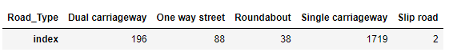

* + On the Single Carriage Way, When the Accident happened the Weather was Fine and No High Wind and the Small no of Accident Occurs in Rain.

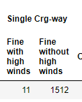

* + Also the Majority of Accident occur on Dry Road Surface i.e. 1446 and Wet Road Surface Value is 265.

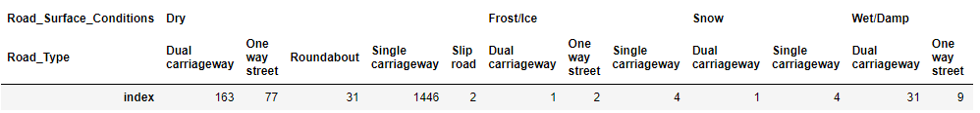

* + In the Urban Areas the Accident no’s are 2007 while Rural areas its 36. 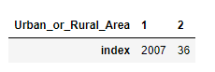

*Visual Representations:*

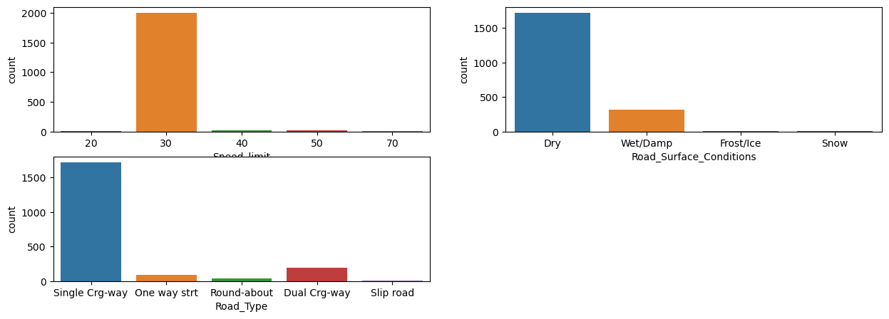

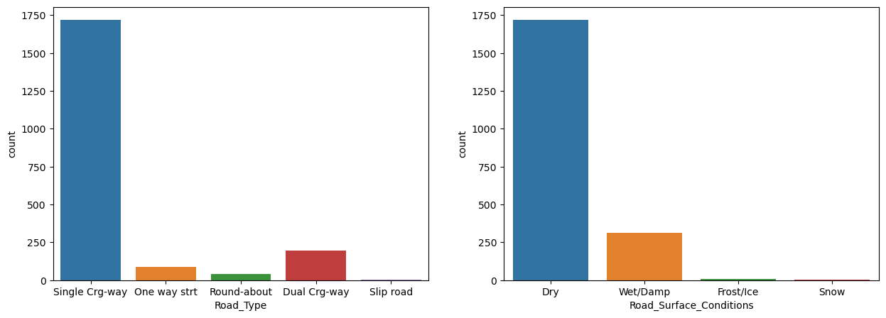

*Summery:*

*Simply we says that the majority of the accidents happened on single carriage way on the day light where their speed was not more then 30kmph and also their road condition was dry.*

***Recommendations:***

1. **Public Awareness Campaigns:**
   * Launch campaigns targeting distracted driving, emphasizing the dangers of using mobile devices while driving.
   * Implement public service announcements during peak commuting hours to raise awareness and promote responsible driving behavior.
2. **Infrastructure Improvements:**
   * Evaluate single carriage way conditions and put proper barricades with the visible colors.
   * Enhance street lighting and visibility at intersections to reduce accidents during nighttime hours.

***Conclusion:***

This data analysis report provides valuable insights into the patterns and contributing factors of road accidents. By addressing key areas such as distracted driving, improving infrastructure, and implementing targeted awareness campaigns, we can work towards reducing the overall incidence and severity of accidents in UK.